For POLICE and INTERNAL USE ONLY

Dear Sir or Madam:

This letter is to introduce Paul Kennedy of eQuality Valuation Services LLC, the firm that has been hired to assist the Assessor and the City of Norfolk in the completion of the 2024 Revaluation.

Paul will be taking photographs of the Residential and Commercial buildings where required. Your cooperation will be greatly appreciated.

Paul’s vehicle will have eQuality Valuation Services magnets. Should you have any questions, please call the Assessor’s Office at (860) 542-5287.

Sincerely,

Rae Ann Walcott
Assessor

Automobile | Color | Plate | 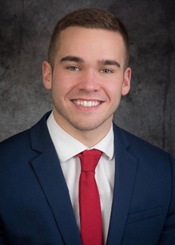
2012 Nissan Altima | Black | AP 59715

eQuality Valuation Services (203) 346-1000

